2019 PROJECT DESCRIPTION FORM

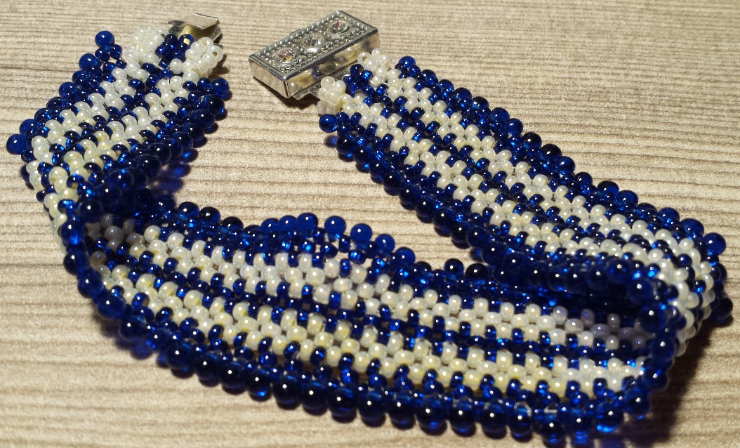
TEACHER: Diane A Ostrander

SESSION PREFERRED: Sunday Afternoon

MAXIMUM/MINIMUM STUDENTS: 12max/1min

PROJECT DESCRIPTION:
The Aenaid Bracelet in Zipper Stitch
Learn a Brand-New Stitch!

Make an elegant, bracelet featuring an exciting new off-loom stitch. Never before published, be one of the first to learn this stich. Easy to master, versatile, with a luscious drape and attractive texture, it will become your new favorite go-to stitch.

COST OF CLASS (does it include kits?) $38 (cash only please) which includes the price of a kit and one set of printed instructions. Kits will include two colors of size 10 or 11 Czech seed beads, 3.2 or 3.5 mm Japanese or Czech mini fringe bead, and one clasp. Class instruction will include information on varying the width of the bracelet, using other beads and bead sizes, and additional information not included in the printed instructions.

KITS AVAILABLE: yes X COST: class price includes working kit described above, however additional kits, and instructions may be available. Prices for additional kits will vary based on kit contents. Instructions alone are $18. All fees, instructions, and kits are cash only, please.
Supply list if no kits available: see below

Tools required: Please bring a task lamp, sharp scissors, and any vision enhancement devices you usually use when crafting or beading. Bring a work surface, such as a bead mat or tray, thread, thread conditioner and/or bees wax. Four or six pound fireline in smoke or crystal is highly recommended for this project. Similar fused braided nylon threads in equivalent weights may be used. Bring beading needles in a size appropriate for your thread choice and size 10 or 11 seed beads.
Please return to Mary Jordan via email to Nona2kandc@gmail.com by October 1, 2018, and include a picture. Please submit one per form with picture attached.

