2019 PROJECT DESCRIPTION FORM
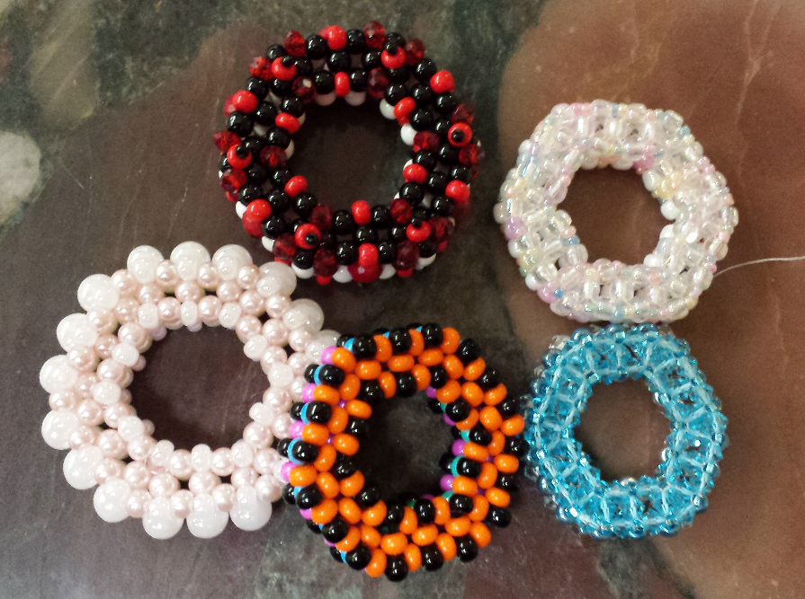

TEACHER: Diane A Ostrander

SESSION PREFERRED: Friday Night

MAXIMUM/MINIMUM STUDENTS: 12max/1min

PROJECT DESCRIPTION: The Hexi Donut
Explore prismatic Right Angle Weave

Create a delightful two-sided focal piece while exploring cubic and prismatic RAW. This double-sided pendant can be made with a variety of bead types, although class kits will include exclusively size 6/º seed beads. Once you have made your first one, you will want to stitch up a handful! Bonus instructions for a RAW beaded chain are included in the kit. Prior experience with Right Angle Weave is preferred. If you are not familiar with this stitch, it is recommended that you practice or research the thread path for basic RAW, before class. You may contact me for a list of sites that offer basic instructions.

COST OF CLASS (does it include kits?) $35 (cash only please) which includes the price of a kit and one set of printed instructions

KITS AVAILABLE: yes X COST: class price includes working kit described above, however additional kits, and instructions may be available. Prices for additional kits will vary based on kit contents. Instructions alone are $15. All fees, instructions, and kits are cash only, please.
Supply list if no kits available: see below

Tools required: Please bring a task lamp, sharp scissors, and any vision enhancement devices you usually use when crafting or beading. Bring a work surface, such as a bead mat or tray, thread, thread conditioner and/or bees wax. Four or six pound fireline in smoke or crystal is required for this project. There are multiple passes through the beads and larger threads will result in bead breakage. Needles should be size 10 and 12. Most work will be done with size 10, however a smaller needle may be needed for tight passes.

Please return to Mary Jordan via email to Nona2kandc@gmail.com by October 1, 2018, and include a picture. Please submit one per form with picture attached.

