PROJECT DESCRIPTION FORM

Toggle Clasp and bracelet
TEACHER: Jan Kurtz
SESSION PREFERRED: Saturday morning
MAXIMUM STUDENTS: 10

PROJECT DESCRIPTION:
A workshop designed to make toggle clasps of your own that can be added to bracelets of your design. Why make nice beads and beaded pieces and use an ordinary purchased clasp when you can make an original and unique one? We will make the clasp and charms, dry to the leather hard stage, smooth and torch fire the charms, and kiln fire the clasp. While the kiln is firing, we will assemble the charms and bracelet elements. Basic techniques including rolling, texturing, shaping, cutting, forming, and finishing will be used. Students will construct the bracelet and add the clasp after firing.
BRING: Magnifying glasses, light source, wire working tools, special beads or charms you may want to use.

CLASS/SUPPLY FEE:
$65 for silver clay to form a the clasp and charms, use of tools and torches, silver wire, chain, pearls and leather bracelet elements, firing and finishing.

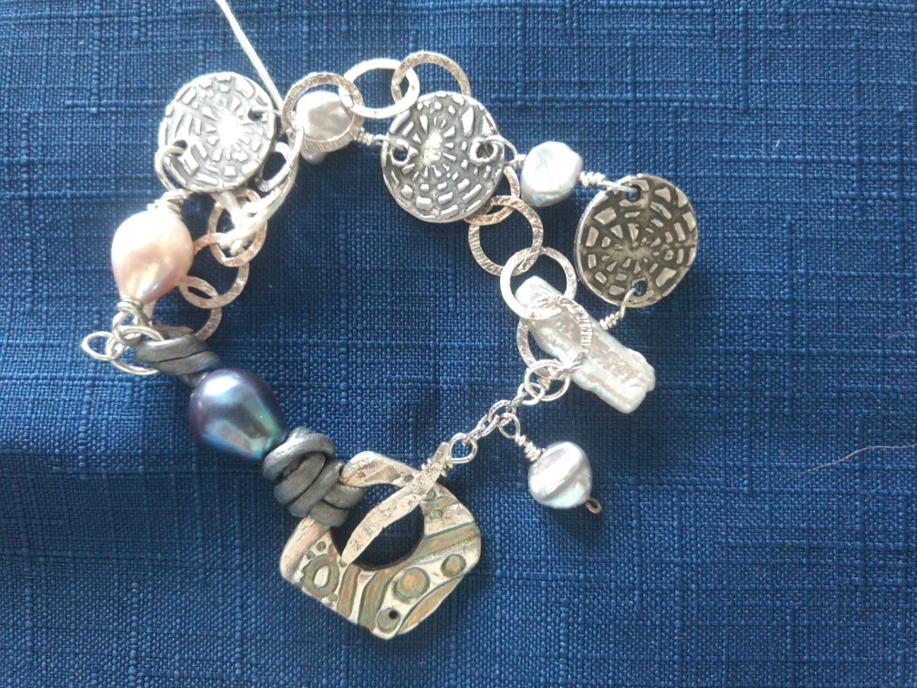

INSTRUCTOR:
Jan Kurtz is a certified Precious Metal Clay Instructor trained in techniques used for jewelry making with fine silver. She is a member of Blue Morning Gallery where both her jewelry and paintings are displayed. Contact her with any questions at jcarolynkurtz@gmail.com

