PROJECT DESCRIPTION FORM

Water etched pendant
TEACHER: Jan Kurtz
SESSION PREFERRED: Friday night
MAXIMUM STUDENTS: 10

PROJECT DESCRIPTION:
The fun technique of water etching will be introduced to enhance a basic pendant. We will design a pendant shape and incorporate a design from a stencil or drawn freehand. Nail polish will be added to the parts of the design to remain elevated. After the polish and the piece are dried, we will use water to etch away the recessed spaces. A jump ring will be made to attach to your pendant for hanging on a chain. The pendant will be dried to the leather hard stage, smoothed and fired. After firing, the pendant will be polished and ready for a chain.
BRING: Magnifying glasses, light source, wire working tools, chain for the pendant (I will have some available for purchase).

CLASS/SUPPLY FEE:
$55 for silver clay to form a pendant and jump ring, use of tools and templates, firing, and finishing.

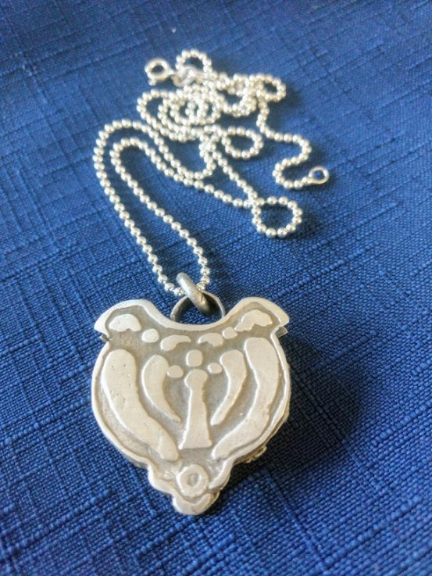

INSTRUCTOR:
Jan Kurtz is a certified Precious Metal Clay Instructor trained in techniques used for jewelry making with fine silver. She is a member of Blue Morning Gallery where both her jewelry and paintings are displayed. Contact her with any questions at jcarolynkurtz@gmail.com

