PROJECT DESCRIPTION FORM

Mixed Metal Earrings
TEACHER: Jan Kurtz
SESSION PREFERRED: Friday night
MAXIMUM STUDENTS: 10

PROJECT DESCRIPTION:
Students will fabricate textured silver elements by rolling out metal clay, texturing, and cutting the clay into shapes. Silver pieces will be dried to the leather hard stage, holes will be added, and pieces will be sanded and torch or kiln fired. Then pieces will be finished by buffing and patina-ing with liver of sulfur. Finished pieces will be combined with copper elements provided in a kit along with earwires and jump rings so that at least one pair of earrings can be completed in class. Advanced students may complete two pairs

BRING: Magnifying glasses, light source, wire working tools, and any metal clay tools you like to use (texture plates, shape cutters, etc, though there will be some available in class for your use.

CLASS/SUPPLY FEE:
$55 for 12.5 g PMC3 silver clay to form two elements for each pair of earrings. Two pairs should be completed in class. Copper elements and sterling silver ear wires and jump rings will be provided.

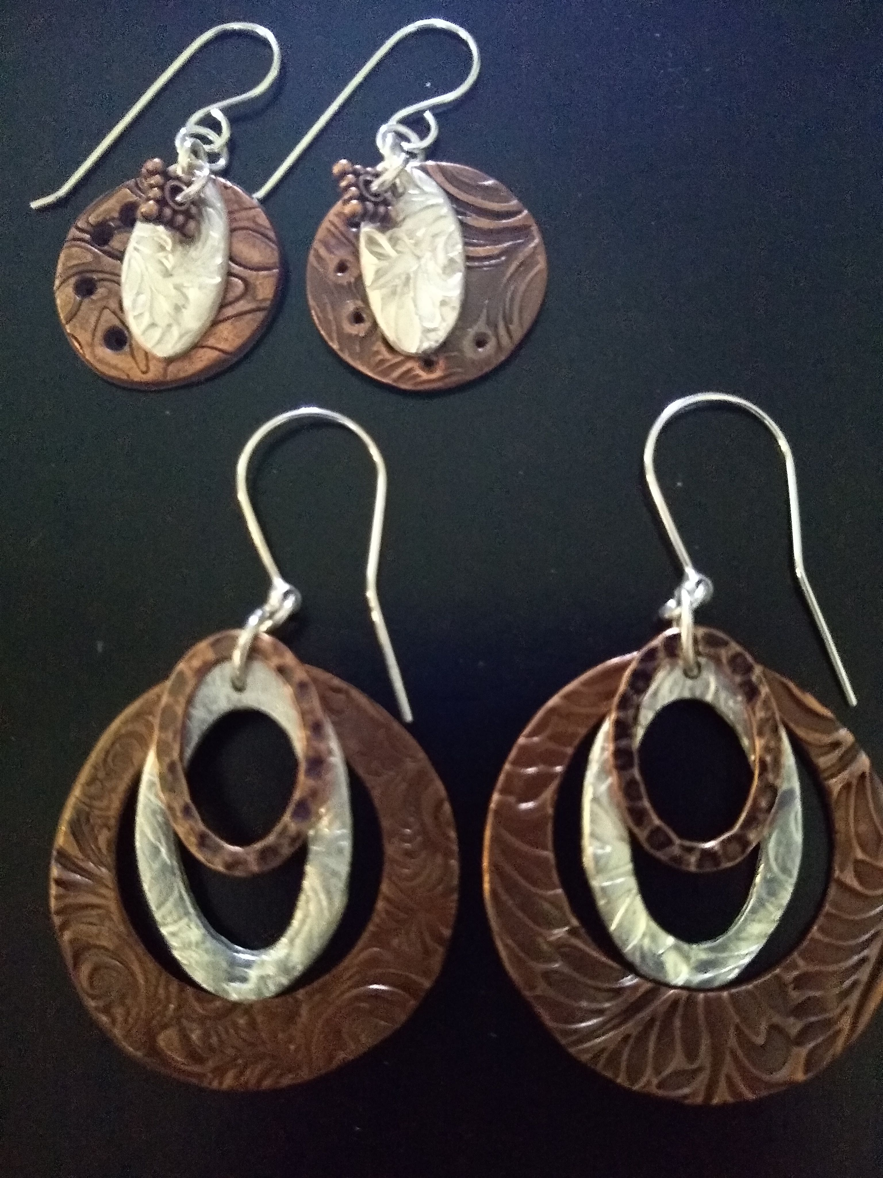

Jan Kurtz is a certified Precious Metal Clay Instructor trained in techniques used for jewelry making. She is a member of Blue Morning Gallery where both her jewelry and paintings are displayed. Contact her with any questions at jcarolynkurtz@gmail.com

