PROJECT DESCRIPTION FORM

Pearl and Charm pendant necklace
TEACHER: Jan Kurtz
SESSION PREFERRED: Sunday morning
MAXIMUM STUDENTS: 10

PROJECT DESCRIPTION:
Students will fabricate a metal clay pendant from PMC3 silver clay. The piece will be dried to leather hard stage, sanded, fired and buffed. Then the pendant base will be enhanced by wiring on pearls and charms to create a statement piece that can be suspended from a chain

BRING: Magnifying glasses, light source, wire working tools, and any metal clay tools you like to use. Students may also wish to bring charms of their liking to incorporate into their design. Three 5 or 6 mm jump rings of at least 20 gauge will be needed, along with a chain of the length you prefer. Chain and jump rings will be available for purchase.

CLASS/SUPPLY FEE:
$55 for 12.5 g PMC3 silver clay to form a pendant base. Wire, pearls and charms will be provided for enhancing the pendant base.

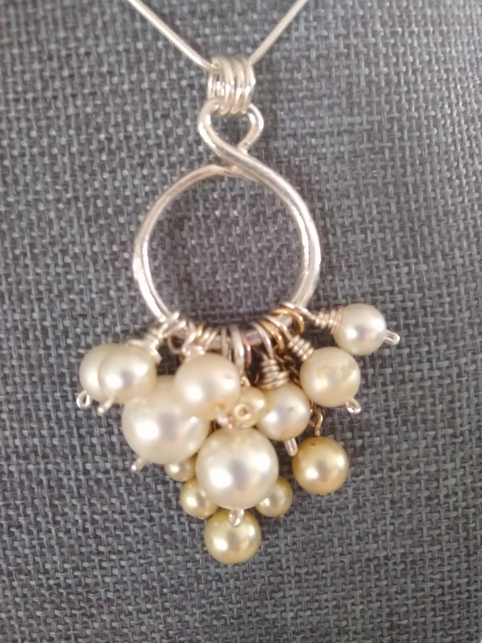

Jan Kurtz is a certified Precious Metal Clay Instructor trained in techniques used for jewelry making. She is a member of Blue Morning Gallery where both her jewelry and paintings are displayed. Contact her with any questions at jcarolynkurtz@gmail.com

